* What is SDLC ?

Ans - SDLC = Software Development Life Cycle

|  |  |
| --- | --- |
| Requirements Collection / Gathering | Establish customer needs |
| Analysis | Model and specify the requirements – “What” |
| Design | Model and specify a solution –“Why” |
|  | Construct a solution In software |
| Testing | Validate the solution against the requirement |
| Maintenance | Repair defects and adopt the solution to the new requirements |

* What is software testing ?

Ans - Software testing is a process used to identify the correctness ,completeness and quality of developed computer software .

* What is agile methodology ?

Ans - It is a combination iterative and increment - divides the software into small incremental builds , this build are provided in iterations , that means the big projects are divided into small chunks (iterations)

- Each iteration last about one to three weeks

- Each iteration involves all the team members , working simultaneously on areas like planning requirement analysis , design , coding , unit testing and acceptance testing.

- At the end of the iteration the working product is displayed to the customer or the important stake holder and it is released in the market

- After the release we check for the feedback of the deployed software

- If any enhancement is needed in the project then it’s done and it’s re - released

*Advantage of Agile method :

- Frequent delivery

- Face to face communication with the customer

- Less time

- Adaptability

*Disadvantage of Agile method :

- Less documentation

- Maintenance problem

* What is SRS ?

Ans - Software requirement specification

* SRS is a complete description of an application which is to be developed
* SRS contains use case diagram that describes all the interaction user will have with the software application
* What is oops ?

Ans - Object oriented programming is way of writing the programs in organized way.

* Write basic concepts oops ?

Ans - Class

* Object
* Inheritance
* Polymorphism
* Over ridding
* Over loading
* Encapsulation
* Abstraction
* What is object ?

Ans - Object gives the permission to access functionality of class.

* What is class ?

Ans - Class is a collection of data member function.

* What is encapsulation ?

Ans - The process wrapping the data in a single unit. To secure the data from outside world

* What is inheritance?

Ans - Making class from an existing class Deriving the attribute of some other class

* What is polymorphism ?

Ans - one name multiple form :

* Type :
* Over riding : Same name of function with same parameter but definition will be different
* Over loading : FUNCTION : Over loading - Same function name but different parameter
* Draw use case on online book shopping?

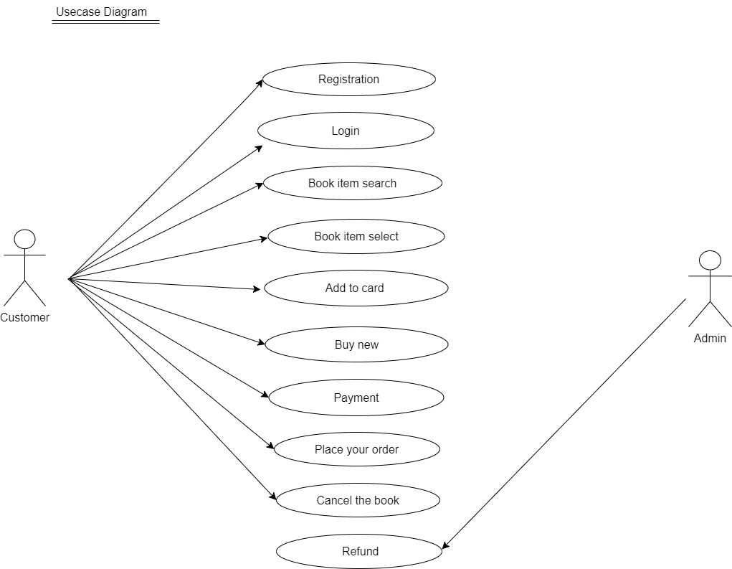

* Draw use case on online bill payment system (paytm)

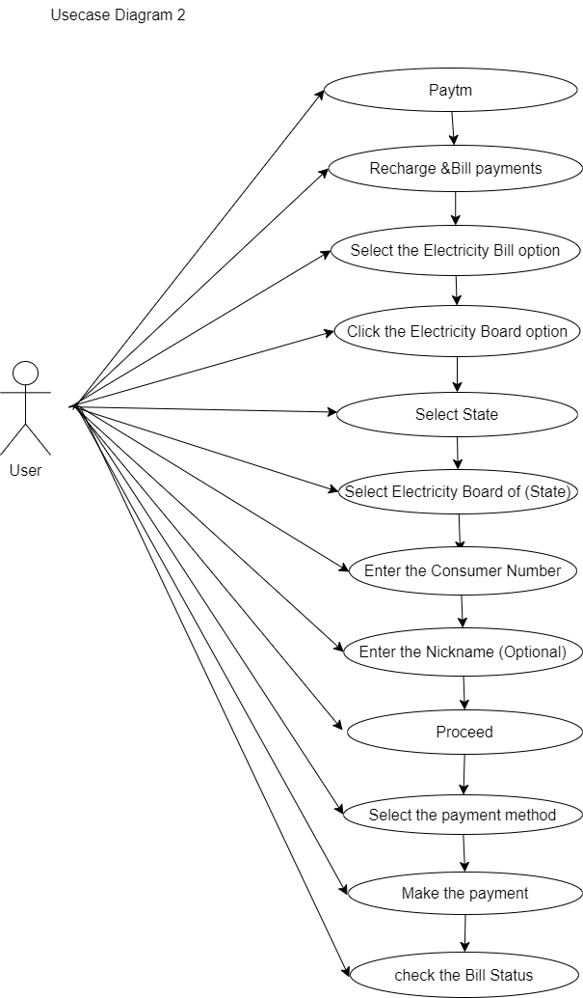

* Write SDLC phases with basic introduction ?

Ans - Requirement Gathering :

Requirement definitions usually consist of natural language , supplemented by (e.g UML) diagrams and tables

1. Functional Requirement : describe system services or functions

* Compute sales tax on a purchase
* Update the database on the server

1. Non Functional Requirement : Are constraints on the system or the development process

* Analysis phase :Details on computer programming languages and environments ,machines , packages , application architecture , distributed architecture , layering , memory size platform , algorithms , data structures ,glohel type definitions , iterfaces &many other engineering & details are established
* Design phase: Implementation plan

Critical priority Analysis

Performance Analysis

Test Plan

* Implementation phase : In the Implementation phase , the team builds the components either from scratch or by composition .
* Testing phase :The testing phase is a separate phase which is a performed by a different team after the implementation is completed
* Maintenance phase : maintenance is the process of changing a system after it has been deployed

1)Corrective maintenance

2)Adaptive maintenance

3)Perfective maintenance

* Explain phases of the waterfall model ?

Ans – Waterfall Model Phase :

- Requirements collection

- Analysis

- Design

- Implementation

- Testing

- Maintenance

* Write phases of spiral model ?

Ans – Spiral Model Phases :

* Planning
* Risk Analysis
* Engineering
* Customer Evaluation
* Write agile manifesto principles ?

Ans

* Explain working methodology of agile model and also write pros and cons ?

Ans - It is a combination iterative and increment - divides the software into small incremental builds , this build are provided in iterations , that means the big projects are divided into small chunks (iterations)

- Each iteration last about one to three weeks

- Each iteration involves all the team members , working simultaneously on areas like planning requirement analysis , design , coding , unit testing and acceptance testing.

- At the end of the iteration the working product is displayed to the customer or the important stake holder and it is released in the market

- After the release we check for the feedback of the deployed software

- If any enhancement is needed in the project then it’s done and it’s re - released

*Advantage of Agile method :

- Frequent delivery

- Face to face communication with the customer

- Less time

- Adaptability

*Disadvantage of Agile method :

- Less documentation

- Maintenance problem

* Draw Use case on online shopping product using COD ?

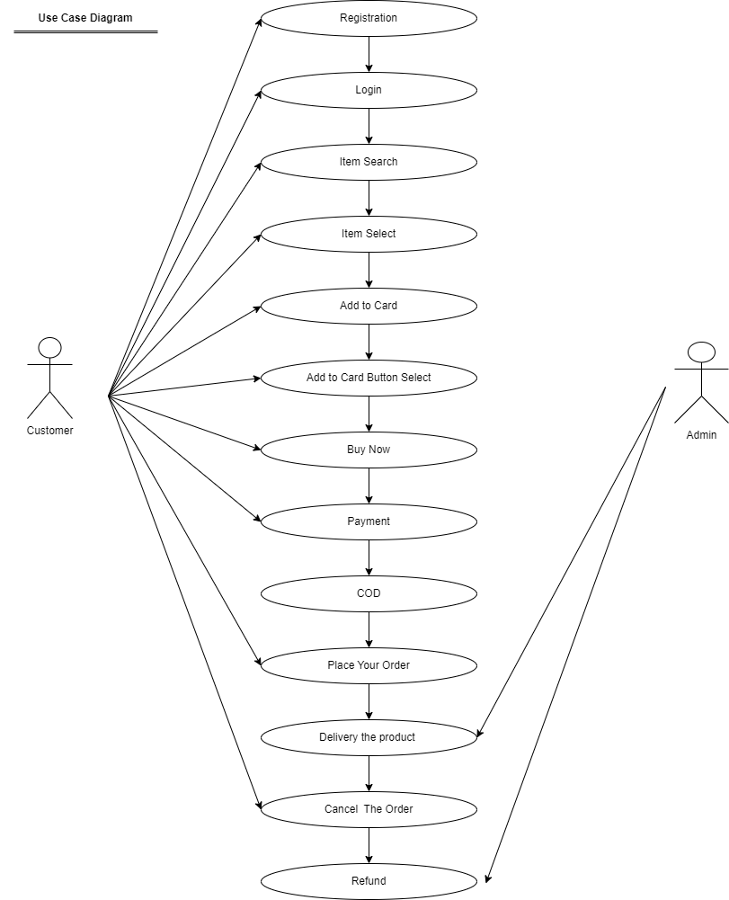

* Draw use case on online shopping product using payment gateway ?

